- Duplicar Bamberg Health

- Actualizar logo
- Ocultar exclusive y news
- Actualizar video por: https://drive.google.com/file/d/1lmjSFSsRyKiF6xC8mkYsYmvprSq6WmyU/view?usp=sharing - CAMBIAR

- Mostrar únicamente el botón Summits


- Cambiar fondo
- Aqui estarán enlistados los próximos 3 eventos. Estos debo poder crearlos desde el admin web



- Quitar sección app
- Cambiar la siguiente sección por:

Cybersecurity & Digital Trust Summit Series
The Bamberg Cybersecurity & Digital Trust Summit Series is our flagship international platform.
Our summits bring together senior cybersecurity, technology, risk, data and government leaders within strategic markets around the world for focused discussions on the most important challenges shaping cybersecurity and digital trust.
CTA: Summits (redirige a los eventos)
Foto de fondo: https://www.flickr.com/photos/194423616@N07/55292837093/in/album-72177720333865969

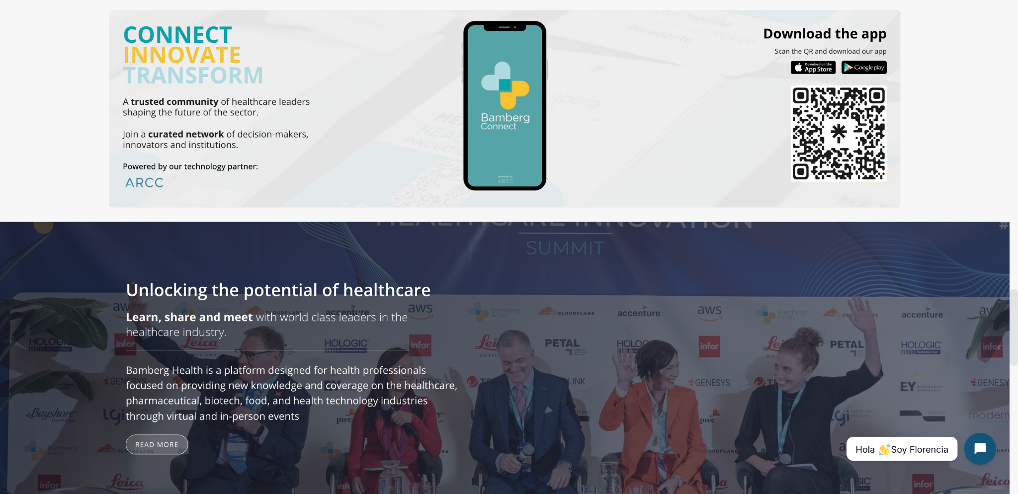

- Many representatives from the industry trust us: inventamos testimonios? revisar redes sociales



- Actualizar logos por: https://drive.google.com/drive/folders/1sSmeBfWpvwBDpIejyb4GGx0WU6PqYqID?usp=drive_link

- Cambiar sección por el siguiente contenido.

Government & Public-Private Collaboration

Strengthening Cybersecurity Through Collaboration
Cybersecurity cannot be addressed by the private sector or government independently.
Bamberg Security facilitates dialogue between government institutions, regulators, critical infrastructure operators and private-sector cybersecurity leaders to encourage greater collaboration around shared digital risks.
Our programs provide a neutral environment where stakeholders can discuss cybersecurity policy, regulation, national cyber resilience, critical infrastructure protection and emerging technological risks.
CTA: Explore opportunities ? y un form de consulta?
Foto: https://www.flickr.com/photos/194423616@N07/55292937709/in/album-72177720333865969
